Dick and Carey Instructional Model
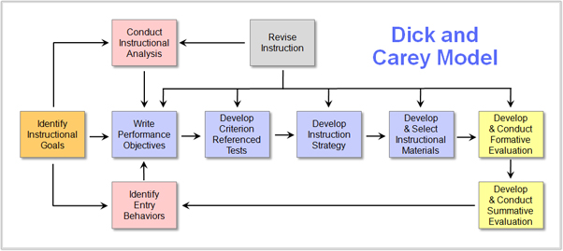
- Identify goals and objectives.
The first step in the Dick and Carey Model is to clarify your goals and objectives. The learner must be aware of what they will be able to do when they complete the eLearning course, including the skills they will develop and the knowledge they will acquire. Make sure that you tie it to real world applications so that they know how the eLearning course can benefit them outside the virtual learning space.
- Complete instructional analysis.
The next step is determining what your learners already know so that you can figure out how to fill the learning gap. This can be done through eLearning assessments, surveys, and interviews that focus on their current skill sets and knowledge base. For example, if the eLearning assessment reveals that a learner is unable to perform a specific on-the-job task, then you integrate the skills and information they need to master the task.
- Determine entry behaviors and learner characteristics.
Conduct audience research to determine your learner’s behaviors, traits, personal preferences, and motivation factors, such as what has prompted them to enroll. Focus on characteristics that pertain directly to the goals and objectives for your eLearning course. This helps you to narrow down the specific online content that is vital for your eLearning course, rather than covering information that they have already acquired. You can identify all of the ideas and concepts that you should include to provide a comprehensive and personalized eLearning experience.
- Write performance objectives.
In addition to the learning goals, you must also develop performance objectives that clearly describe the task or process that must be mastered, as well as criteria that you are going to gauge learner progress. The performance objectives must also include the specific conditions in which the task or skill will be carried out, such as observing your audience on-the-job or in a particular real-world setting.
- Develop criterion-referenced eLearning assessments.
No eLearning strategy is complete without an effective online assessment plan. This involves finding the ideal eLearning assessment type for your learners, such as the multiple-choice questions or interactive scenarios, as well as the grading rubric and criteria. Though formative and/or summative eLearning assessment, you can also determine if the instructional strategy, itself, is effective and reveal the weaknesses and strengths of the online activities and exercises of the eLearning course.
- Develop the instructional eLearning strategy.
Now that you’ve done all of the research and developed your objectives and goals, it is time to create a sound instructional eLearning strategy for your audience. You should take into consideration the learning theories that are best suited for your subject matter and learner needs, based on which you will develop the eLearning activities that properly convey the desired information to your learners.
- Choose learning materials and online activities.
Select each of the learning materials, tools, and online exercises that serve the learning goals and objectives. This also involves eLearning content creation, such as online tutorials, branching scenarios, and text and multimedia-based instructional aids. You should also consider the preferences of your learners when choosing your online materials, and include a wide range of eLearning activities to appeal to a wider audience.
- Carry out formative evaluation.
This takes place even before you unveil your eLearning course to the public. It often involves focus groups or the release of beta versions that help to iron out any issues prior to eLearning course deployment. If you find any weak areas in the eLearning course, now is the time to fix them and ensure that every element is as effective as possible. This may require a major rewrite of your eLearning content or even revamping your online activities, if necessary. Keep in mind that it’s better to remedy the problems now, rather than risking your brand image with a flawed eLearning course later on.
- Carry out summative evaluation.
The last step is assessing whether your eLearning course actually achieves the desired outcome. This can only truly be determined through learner post-assessments, such as tests at the end of the lesson, and performance-based online exams, like observing a learner on-the-job or examining business statistics. An example of this would be to check customer satisfaction scores to discover if a customer service eLearning course had the desired effect.

